Jenkins task for Assignment-01

1) Install Jenkins and run Jenkins on port number 8081.
1
- Install Java (if not installed):
bash
sudo apt update
sudo apt install openjdk-11-jdk -y
- Add Jenkins repository and install Jenkins:
bash
wget -q -O - https://pkg.jenkins.io/debian/jenkins.io.key | sudo apt-key add -
sudo sh -c 'echo deb https://pkg.jenkins.io/debian binary/ > /etc/apt/sources.list.d/jenkins.list'
sudo apt update
sudo apt install jenkins -y
- Edit Jenkins config to run on port 8081:
bash
sudo nano /etc/default/jenkins
# Change HTTP_PORT=8080 to HTTP_PORT=8081
- Restart Jenkins:
bash
sudo systemctl restart jenkins
sudo systemctl status jenkins
- Open in browser:
http://localhost:8081
2 Jenkins Installation & Setup
- Install Java (required for Jenkins):
sudo dnf install -y java-17-amazon-corretto
Verify using: java --version
- Add Jenkins repository, import the key:
  - Download repo using wget
  - Import using rpm
- Install Jenkins:
sudo yum install -y Jenkins
- Start and enable Jenkins service:
text
sudo systemctl start jenkins
sudo systemctl enable Jenkins
systemctl status Jenkins
- Change Jenkins port (default 8080 → 8081):
  - Edit /usr/lib/systemd/system/jenkins.service
  - Update Environment="JENKINS_PORT=8081"
  - Reload and restart:
text
sudo systemctl daemon-reexec
sudo systemctl daemon-reload
sudo systemctl restart jenkins

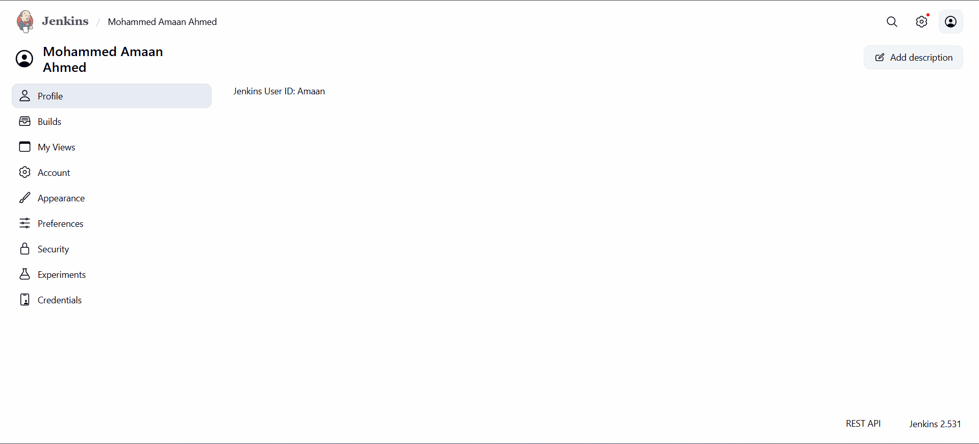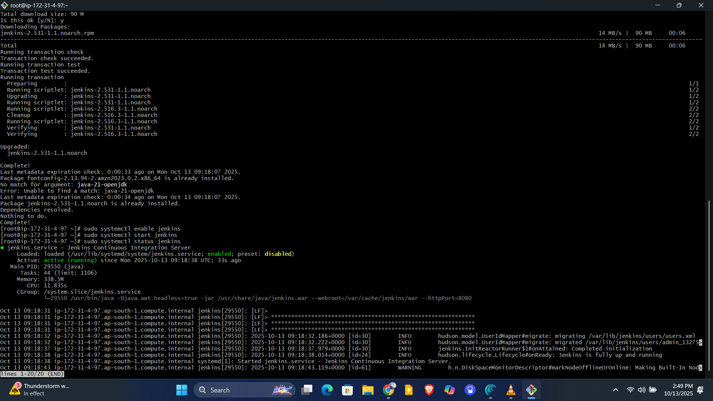

2) Secure Jenkins server
Securing Jenkins
- First login requires initial admin password:
Location: /var/lib/jenkins/secrets/initialAdminPassword
- Create a new admin user and disable/delete the default admin account for security reasons.

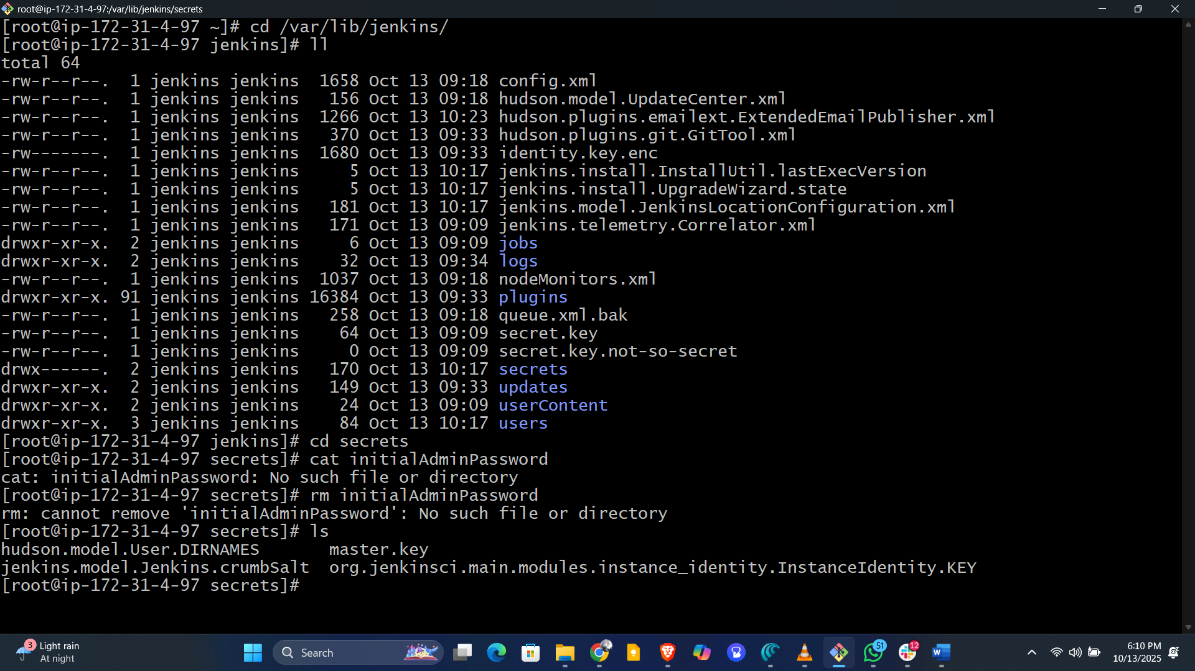

3) Create users called DevOps, Testing in Jenkins with Limited access.
Create Limited Access Users
- Go to Manage Jenkins > Plugins, search, and install Role-based Authorization Strategy.
- Restart Jenkins after plugin installation.
- Steps to create users:
  - Manage Jenkins > Security > Manage Users → Create users: e.g., DevOps, Testing
  - Assign project-based matrix authorization to provide limited access.
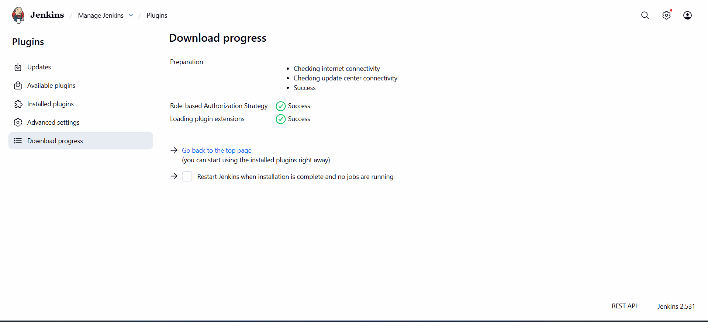

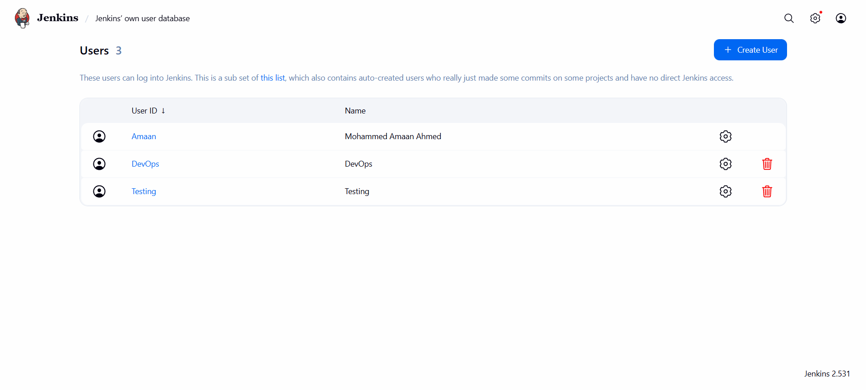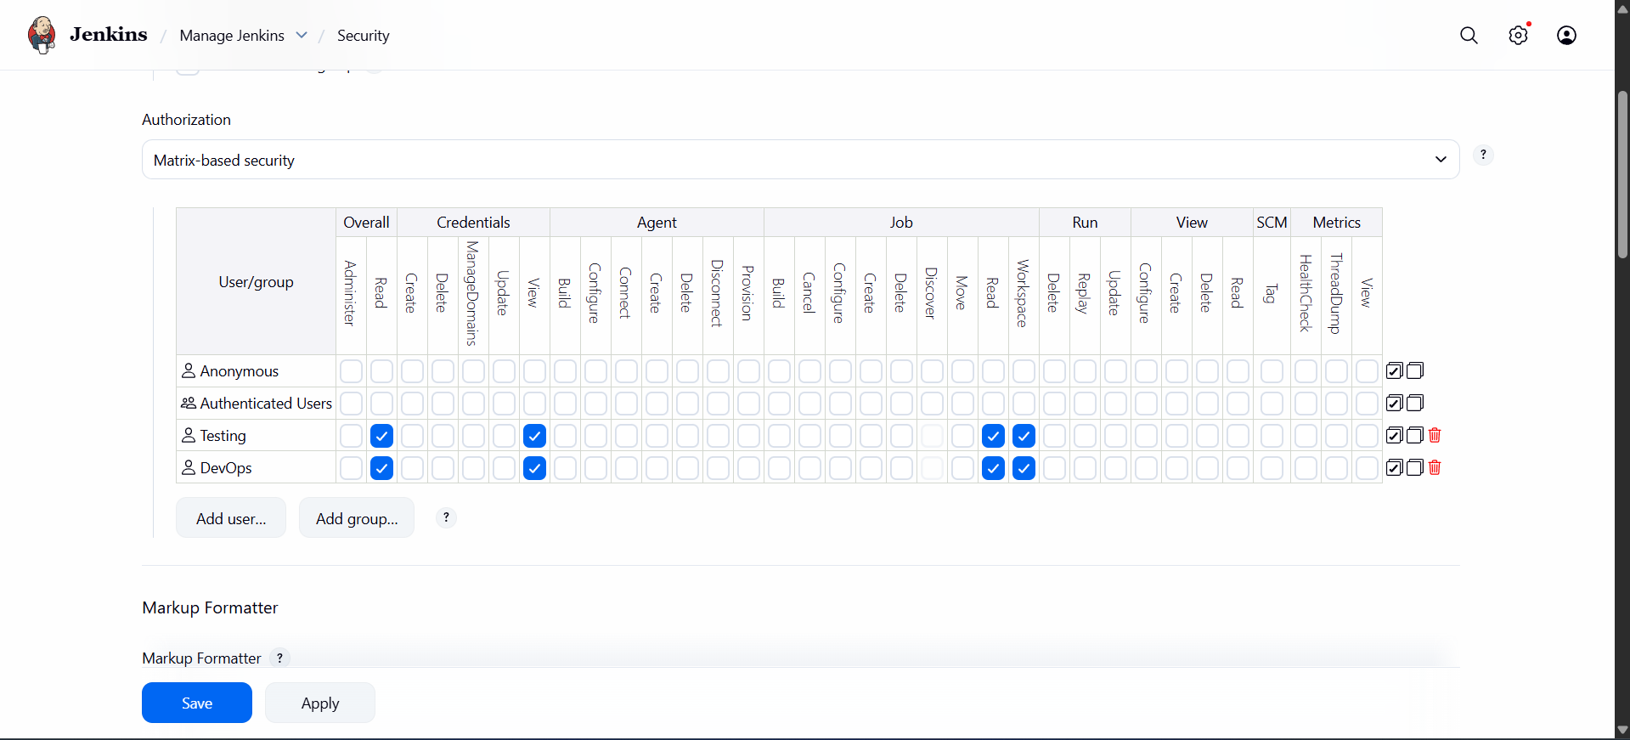

4) Configure labels and restrict the jobs to execute based on label only.

Configure Labels and Restrict Job Execution
- Assign labels to nodes:
Manage Jenkins > System → set label name for node
- Restrict jobs by label:
  - Job configuration → General → “Restrict where this project can be run” → Enter label name
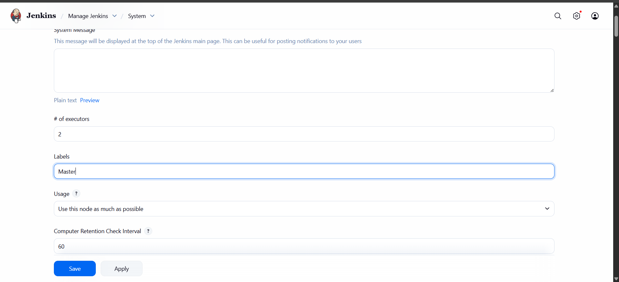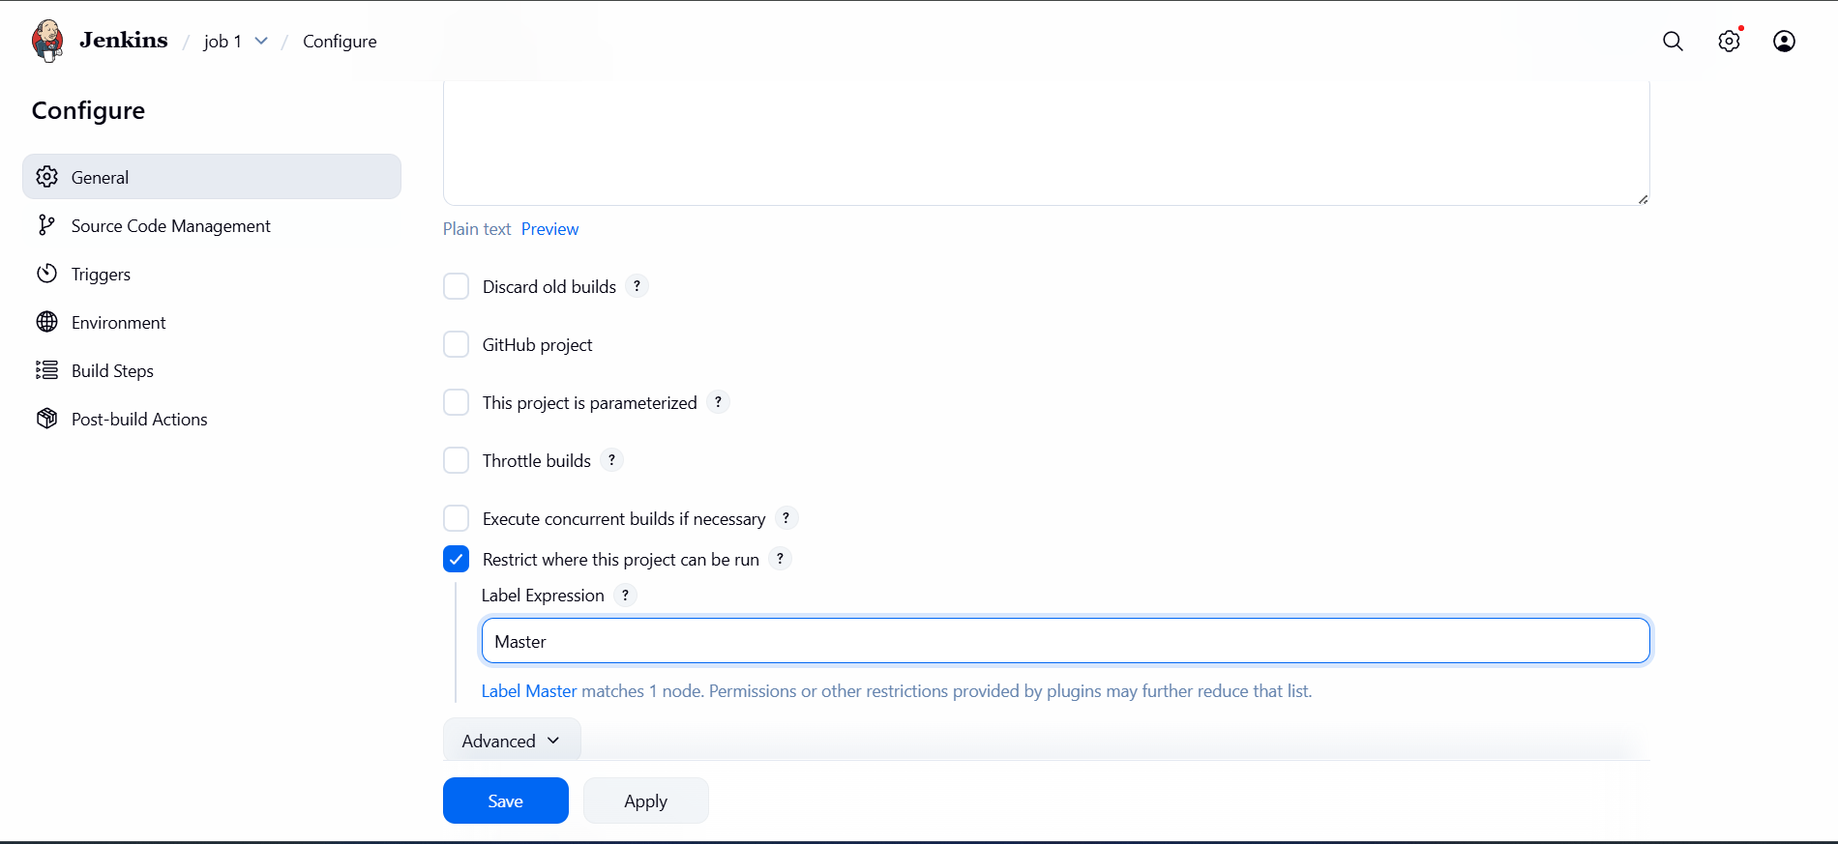

5) Create Three sample jobs using the below URL.
https://github.com/betawins/Techie_horizon_Login_app.git

Create Sample Jobs from GitHub (Public Repository)
- Ensure Git is installed:
yum install git
- 3 sample jobs:
  - New Item → Freestyle Project → Source Code Management → Git → Enter repo URL (https://github.com/betawinsTechiehorizonLoginapp.git)
  - Save and build each project.
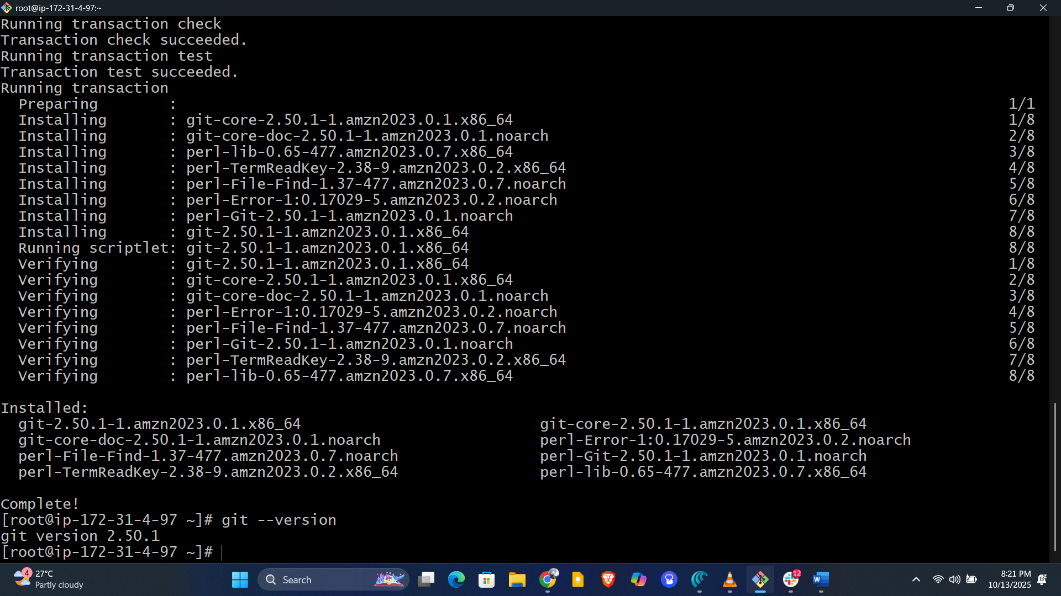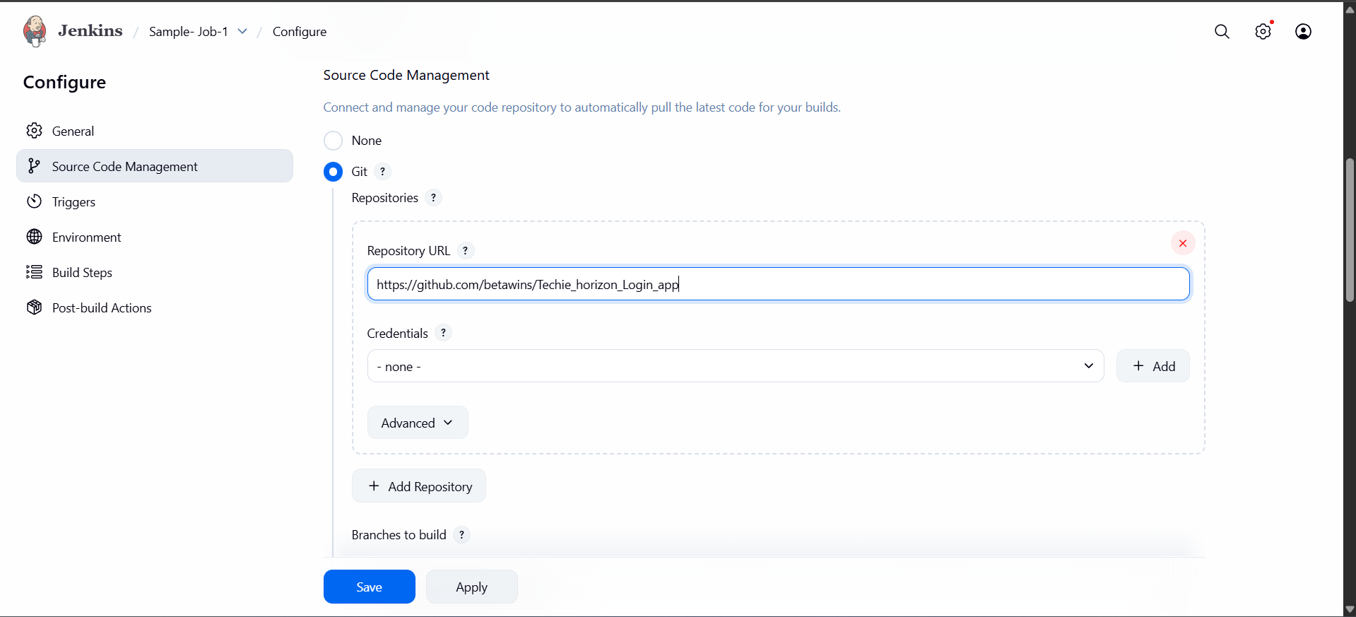

6. Create one Jenkins Job using a Private GitHub Repository

- New Item > Enter job name > Freestyle/project > OK.
- In Source Code Management, select “Git”.
- Enter your private repo URL (format: https://github.com/<username>/<private-repo>.git).
- Click “Add” to enter credentials (username/password, or token for GitHub).
- Assign a label if needed.
- Add build steps as required.
- Save and Build.
